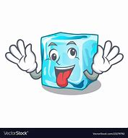
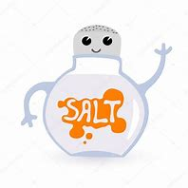
Have you ever wondered why the council adds
Q; Does salt affect the rate at which ice melts?
salt and grit to the roads when icy weather is forecast?
C3 Super Scientists Mission
In groups of 3, your task is to come up with an investigation to answer this question. You will receive no assistance from Miss Tose - only a list of possible equipment.
Does salt do something to the melting point of ice?

Equipment:
- Ice cubes
- Salt
- Beaker
- Funnel
- I pad for timer
- Teaspoons
- Digital thermometers
- Digital scales
Method:
- ________________________________________________________________________________________________________________________
- ________________________________________________________________________________________________________________________
- ________________________________________________________________________________________________________________________
- ________________________________________________________________________________________________________________________________________________________________
- ________________________________________________________________________________________________________________________________________________________________

Fair testing:

Variables that stay same | Variables that change

Diagram:

Results:
(Think carefully how to record your results)

Conclusion:

